NATIONAL UNIVERSITY OF SINGAPORE

EXAMINATION FOR
(Semester II: 2007/2008)

EE4212 – COMPUTER VISION
April / May 2008 - Time Allowed: 2 Hours

Instructions to Candidates:
1. This paper contains FOUR (4) questions and comprises SIX (6) printed pages.
2. Answer all FOUR (4) questions.
3. All questions carry equal marks.
- This is a CLOSED BOOK examination but candidates are allowed to bring in ONE (1) A4 sheet of paper, on which they may write any information, into the examination hall.
5. Programmable calculators can be used in the examination.

Q1
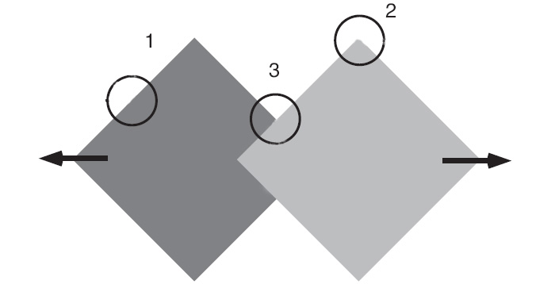

Figure 1a. Two squares translating horizontally in the opposite directions.

- In Figure 1a, the two squares are translating horizontally in the opposite directions as indicated by the arrows. Indicate the respective perceived motions if you are looking through the apertures 1, 2, and 3. Explain your answers.
(6 marks)

- Given that focal length f =1, focus of expansion (x₀, y₀) = (0, 0), and that the rotation velocity is of the form ω = (α, 0, 0). The optical flows at the following three feature points (1, 0), (0, 1), and (1, 1) are given respectively by (1, 0.1), (0, 1.2), and (1.1, 1.2). All the above quantities are given in pixel units.
- Write down for the three feature points the respective unit vectors along which there is no translational flow.
- Suggest how you would recover α from the optical flow measured at point (1, 0).
(4 marks)

- You see a first image of a cube with a perspective projection camera with focal length f. The image of the whole cube lies within the image. Then you rotate the camera around its center of projection to obtain new images. Can you get any structural information about the cube by this camera motion? Can you see a new facet that you were not seeing in the first image?
(6 marks)

- Compute the Fundamental matrix F for a non-verged stereo camera system (i.e. parallel cameras with their optical axes perpendicular to the baseline) with 10 micron per pixel in both dimensions and a 12.5mm focal length f. The image dimension is 600×800 (row×column) in pixels and the center of projection is in the middle of the image. The baseline is 100mm.
(9 marks)
Q2
(a) Write down the values for a, b, c, and d so that the homogeneous 3-vectors (1, a, b) ~ (−½, 3, 4) and (c, d, 2) ~ (3, 0, 1), where ~ represents the equivalence relationship .
(2 marks)

(b) Determine the homogeneous 3-vector that represents the line at infinity, defined as the line that contains the set of all points at infinity (x₁, x₂, 0). Determine the point in P² at which the line through (a, 0, 1) and (0, b, 1) meets the line at infinity.
(6 marks)

(c) Give the general condition when an infinite line in 3D space yields an infinite 2D line on the image plane under the perspective projection model.
(2 marks)

(d) In a stereo pair, if both epipoles are located within the two images, will the cameras see each other in the images? In order to compute the epipole, what is the necessary condition on the rank of the estimated Fundamental matrix F? How do you impose this rank condition when the estimated F is perturbed by noise?
(7 marks)

- Let t : R²→ R² maps image points (x₁′, y₁′) to (x₂′, y₂′) as follows:

x₂′= a x₁′ + b and y₂′= c y₁′ + d

The euclidean plane R² can be embedded into the projective plane P² through the coordinate substitution x′ = x/w, y′ = y/w. Write the mapping above as a projective transformation
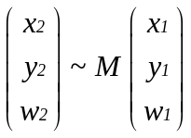

and give the corresponding 3x3 matrix M. Show each step of your working clearly and how your mapping indeed reproduces the original mapping t : R²→ R².
(8 marks)

